**AIM: -** Study of Amplitude modulation and demodulation

**Software used: -** Multisim.

**Theory:** Amplitude Modulation is defined as a system of modulation in which the amplitude of the carrier is made proportional to the instantaneous amplitude of the modulating signal.

The standard form of an amplitude modulated (AM) wave is defined by V=(V+mVsint)sina

Where m is a constant called the amplitude sensitivity of the modulator.

The demodulation circuit is used to recover the message signal from the incoming AM wave at the receiver An envelope detector is a simple and yet highly effective device that is well suited for the demodulation of AM wave, for which the percentage modulation is less than 100%. Ideally, an envelope detector produces an output signal that follows the envelop of the input signal wave form exactly; hence, the name. Some version of this circuit is used in almost all commercial AM radio receivers.

**Circuit: -**

**Output: -**

**AIM: -** Study of pulse amplitude modulation (PAM).

**Software used: -** Multisim.

Theory -There are different kinds of modulation technique based on varying the properties of a pulse train. There is a simple pulse modulation technique called Pulse Amplitude Modulation (PAM) which is proved to be more power efficient and consumes constant power for individual pulses. In PAM the amplitude of the individual pulses are varied according to the amplitude of the modulating signals. The PAM modulator and demodulator circuits simple compared to other kind of modulation and demodulation techniques. There are two kinds of PAM, one in whichh the pulses have the same polarity and the other in which the pulses can have both positive and negative polarity according to the amplitude of the modulating signal.

**Circuit: -**

**Output: -**

**AIM: -** Study of pulse width modulation (PWM)

**Software used: -** Multisim.

**Theory-**

Pulse Width Modulation (PWM) is a form of pulse modulation where the width of the pulses in a carrier pulse train is made proportional to the instantaneous amplitude of the modulating signal. A pulse width modulator circuit is made up of 555 Timer is shown in figure 2.1. Here the 555 timer is working in monostable mode. A negative trigger pulse at pin 2 sets the output. The modulating signal is applied to the control pin of the 555, which varies the threshold voltage. This in turn varies the charging time of capacitor C2 and makes the trailing edge of the output pulse proportional to the modulating signal. Thus the trigger pulse that occurs periodically decides the leading edge of the output pulse and the trailing edge is proportional to the amplitude of the modulating signal. The resulting output will be pulse width modulated.

**Circuit: -**

**Output: -**

**AIM: -** Study of Frequency modulation

**Software used: -** Multisim.

**Theory:**

Frequency modulation is a system in which the amplitude of the modulated carrier is kept constant, while its frequency and rate of change of frequency are varied by the modulating signal. The amount by which the carrier frequency is varied from its unmodulated value is called the deviation. Deviation is made proportional to the instantaneous amplitude of the modulating signal.

The instantaneous frequency f of the frequency modulated wave is given by ffc(1+kVm. CONto) where f.Unmodulated carrier frequency k-Proportionality constant Vm-coswmt- Instataneous modulating voltage The maximum deviation occur when cost = ±1 Under this condition, the instantaneous frequency will be f=f(1±kv) Maximum deviation & fekv The instantaneous amplitude of the FM signal is given by

P A sin (ωt+ sin ot) Im

**Circuit: -**

**Output: -**

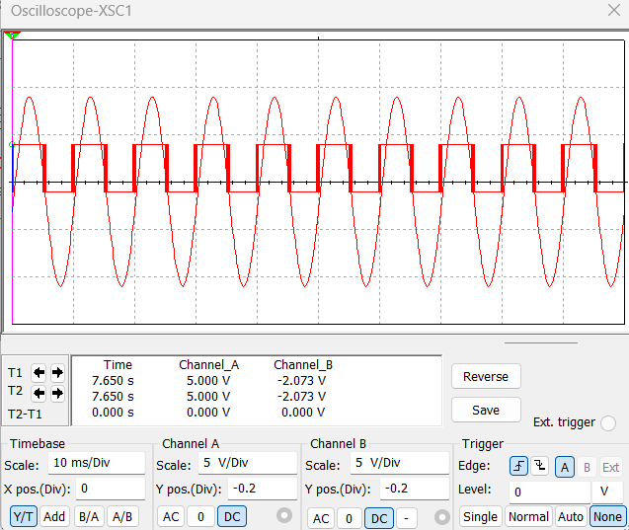

**AIM: -** Study of Delta modulation

**Software used: -** Multisim.

**Theory:**

Delta modulation is the differential pulse code modulation scheme in which different signal is encoded into a single bit, in digital transmission system the analog signal is sampled & digitally coded, this code represent the sampled amplitude of the analog signal. The digital signal is sent to the receiver through any channel in serial form. At the receiver the digital signal is decoded & filtered to get reconstructed analog signal sufficient no, of samples are required to allow the analog signal to be reconstructed accurately. DM is an encoding process where logic levels of the transmitted pulses indicate whether the decoded o/p should rise or fall at each pulse.

**Circuit: -**

**Output: -**

**AIM: -** Study of pulse position modulation (PPA)

**Software used: -** Multisim.

Theory- Modulation of a pulse carrier wherein the value of each instantaneous sample of a modulating wave varies the position in time of a pulse relative to its unmodulated time of occurrence. As the name implies, PPM is a data-encoding scheme where the position of the transmitted pulses is modified. Typically this will result in a long stream of pulses that are unevenly spaced in time. Pulse position modulation (PPM) use pulses that are of uniform height and width but displaced in time from some base position according to the amplitude of the signal at the instant of sampling. The position of each pulse, in relation to the position of a recurrent reference pulse, is varied by each instantaneous sampled value of the modulating wave. Pulse position modulation is also sometimes known as pulse-phase modulation.

**

**Output: -**

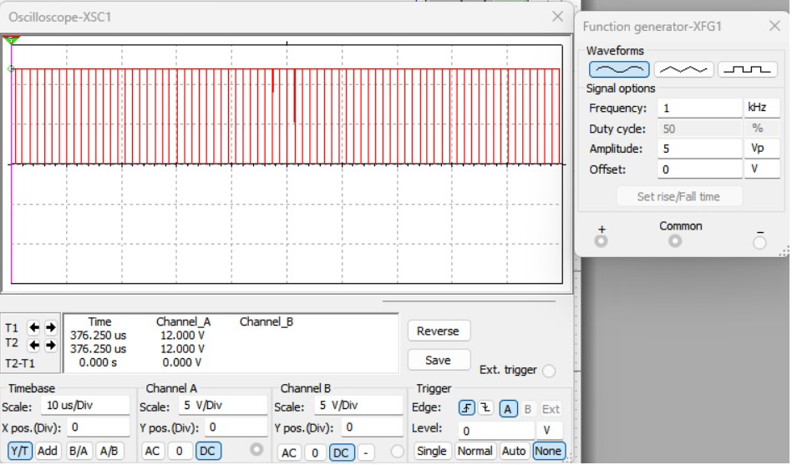

**AIM: -** Study of Adaptive delta modulation (ADM)

**Software used: -** Multisim.

Theory:- Adaptive delta modulation (ADM) or continuously variable slope delta modulation

(CVSD) is a modification of DM in which the step size is not fixed. Rather, when several consecutive bits have the same direction value, the encoder and decoder assume that slope overload is occurring, and the step size becomes progressively larger. Otherwise, the step size becomes gradually smaller over time. ADM reduces slope error, at the expense of increasing quantizing error. This error can be reduced by using a low pass filter ADM provides robust performance in the presence of bit errors meaning error detection and correction are not typically used in an ADM radio design, this allows for a reduction in host processor workload.

**Circuit:**

**Output: -**

